“FORM 1  THE PATENTS ACT 1970 (39 of 1970) and  THE PATENTS RULES, 2003  APPLICATION FOR GRANT OF PATENT  (See section 7, 54 and 135 and sub-rule (1) of rule 20) |  |  |  |  |  | (FOR OFFICE USE ONLY)
 |  |  |  |  | Application No.
 |  |  |  |  | Filing date:
 |  |  |  |  | Amount of Fee paid:
 |  |  |  |  | CBR No:
 |  |  |  |  | Signature:
1. APPLICANT’S REFERENCE /
IDENTIFICATION NO. (AS ALLOTTED BY
OFFICE)
2. TYPE OF APPLICATION [Please tick (✓) at the appropriate category]
Ordinary (✓ ) |  | Convention ( ) |  |  |  |  | PCT-NP ( )
Divisional  ( ) | Patent of  Addition ( ) | Divisional  ( ) |  | Patent of  Addition ( ) |  |  | Divisional  ( ) |  |  |  | Patent of Addition ( )
3A. APPLICANT(S)
Name in Full |  | Nationality | Country of  Residence |  |  |  | Address of the Applicant
K.S.Rangasamy College of Technology |  | Indian | India |  |  |  | Address
 |  |  |  |  |  |  | Street |  |  |  | KSR Kalvi Nagar
 |  |  |  |  |  |  | City |  |  |  | Tiruchengode
 |  |  |  |  |  |  | State |  |  |  | Tamil Nadu
 |  |  |  |  |  |  | Country |  |  |  | India
 |  |  |  |  |  |  | Pin code |  |  |  | 637 215
3B. CATEGORY OF APPLICANT [Please tick (✓ ) at the appropriate category]
Natural Person (✓) |  | Other than Natural Person
 |  | Small Entity ( ) |  |  |  | Startup ( ) |  |  |  | Others ( )
4. INVENTOR(S) [Please tick (✓) at the appropriate category]
Are all the inventor(s)  same as the applicant(s) named above? |  | Yes ( ) |  |  |  |  |  | No (✓ )

If “No”, furnish the details of the inventor(s)
Name in Full |  | Nationality |  | Country of  Residence |  |  | Address of the Inventor
 |  | Indian |  | India |  |  | Address |  | Associate Professor / CSE
 |  |  |  |  |  |  | Street |  | KSR Kalvi Nagar
 |  |  |  |  |  |  | City |  | Tiruchengode
 |  |  |  |  |  |  | State |  | Tamil Nadu
 |  |  |  |  |  |  | Country |  | India
 |  |  |  |  |  |  | Pin code |  | 637215
 |  |  |  |  |  |  | Phone No |  | 9994312842
 |  |  |  |  |  |  | E-mail ID |  | chithra@lsrct.ac.in
 |  |  |  |  |  |  | Category (Gen,OBC,SC/ST) |  | OBC
Dr. ARTHANARIESWARAN V P |  | Indian |  | India |  |  | Address |  | Professor / MECH
 |  |  |  |  |  |  | Street |  | KSR Kalvi Nagar
 |  |  |  |  |  |  | City |  | Tiruchengode
 |  |  |  |  |  |  | State |  | Tamil Nadu
 |  |  |  |  |  |  | Country |  | India
 |  |  |  |  |  |  | Pin code |  | 637215
 |  |  |  |  |  |  | Phone No |  | 9942522923
 |  |  |  |  |  |  | E-mail ID |  | vpaeswaran2000@gmail.com
 |  |  |  |  |  |  | Category (Gen,OBC,SC/ST) |  | OBC
Dr. VANITHA K |  | Indian |  | India |  |  | Address |  | Professor / ECE
 |  |  |  |  |  |  | Street |  | KSR Kalvi Nagar
 |  |  |  |  |  |  | City |  | Tiruchengode
 |  |  |  |  |  |  | State |  | Tamil Nadu
 |  |  |  |  |  |  | Country |  | India
 |  |  |  |  |  |  | Pin code |  | 637215
 |  |  |  |  |  |  | Phone No |  | 9865028854
 |  |  |  |  |  |  | E-mail ID |  | vanitha@ksrct.ac.in
 |  |  |  |  |  |  | Category (Gen,OBC,SC/ST) |  | OBC
ACKSHAYA R |  | Indian |  | India |  |  | Address |  | Student / CSE
 |  |  |  |  |  |  | Street |  | KSR Kalvi Nagar
 |  |  |  |  |  |  | City |  | Tiruchengode
 |  |  |  |  |  |  | State |  | Tamil Nadu
 |  |  |  |  |  |  | Country |  | India
 |  |  |  |  |  |  | Pin code |  | 637215
 |  |  |  |  |  |  | Phone No |  | 6369750408
 |  |  |  |  |  |  | E-mail ID |  | ackshaya2003@gmail.com
 |  |  |  |  |  |  | Category (Gen,OBC,SC/ST) |  | OBC
DHINAKARAN T |  | Indian |  | India |  |  | Address |  | Student/ CSE
 |  |  |  |  |  |  | Street |  | KSR Kalvi Nagar
 |  |  |  |  |  |  | City |  | Tiruchengode
 |  |  |  |  |  |  | State |  | Tamil Nadu
 |  |  |  |  |  |  | Country |  | India
 |  |  |  |  |  |  | Pin code |  | 637215
 |  |  |  |  |  |  | Phone No |  | 9361468184
 |  |  |  |  |  |  | E-mail ID |  | dhinakarant104@gmail.com
 |  |  |  |  |  |  | Category (Gen,OBC,SC/ST) |  | OBC
5. TITLE OF THE INVENTION
Voice Based Health Assistant for Elderly with Multi-Language and Offline support
6. AUTHORISED REGISTERED PATENT  AGENT(S) |  |  |  |  | IN/PA No.
 |  |  |  |  | Name
 |  |  |  |  | Mobile No.
7. ADDRESS FOR SERVICE OF APPLICANT IN INDIA |  |  |  |  | Name |  |  | K.S.Rangasamy College of Technology
 |  |  |  |  | Postal Address |  |  | KSR Kalvi Nagar of Tiruchengode-637 215
 |  |  |  |  | Telephone No.
 |  |  |  |  | Mobile No. |  |  | 98654 55555
 |  |  |  |  | Fax No.
 |  |  |  |  | E-mail ID |  |  | principal@ksrct.ac.in
8. IN CASE OF APPLICATION CLAIMING PRIORITY OF APPLICATION FILED IN CONVENTION
COUNTRY, PARTICULARS OF CONVENTION APPLICATION
Country | Application  Number | Filing date | Name of the applicant |  |  | Title of the invention |  | IPC (as classified in the convention country)
9. IN CASE OF PCT NATIONAL PHASE APPLICATION, PARTICULARS OF INTERNATIONAL APPLICATION FILED UNDER PATENT CO-OPERATION TREATY (PCT)
International application number |  |  |  | International filing date
10. IN CASE OF DIVISIONAL APPLICATION FILED UNDER SECTION 16, PARTICULARS OF ORIGINAL (FIRST) APPLICATION
Original (first) application No. |  |  |  | Date of filing of original (first) application

11. IN CASE OF PATENT OF ADDITION FILED UNDER SECTION 54, PARTICULARS OF MAIN APPLICATION OR PATENT
Main application/patent No. | Date of filing of main application
12. DECLARATIONS
(i) Declaration by the inventor(s)
(In case the applicant is an assignee: the inventor(s) may sign herein below or the applicant may upload the assignment or enclose the assignment with this application for patent or send the assignment by post/electronic transmission duly authenticated within the prescribed period).
We, the above named inventor(s) is/are the true & first inventor(s) for this Invention and declare that the applicant(s) herein is/are my/our assignee or legal representative.
- Date
- Signature(s)
- Name(s)

Date: 19th day of September 2025.  Signature:  Name: Dr. CHITHRA R | Date: 19th day of September 2025.  Signature:   Dr. ARTHANARIESWARAN V P | Date: 19th day of September 2025.  Signature: 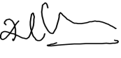  Name:  Dr. VANITHA K
Date: 19th day of September 2025.  Signature: 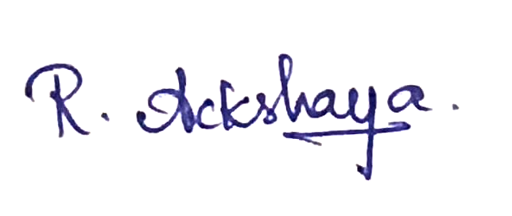  Name: ACKSHAYA R | 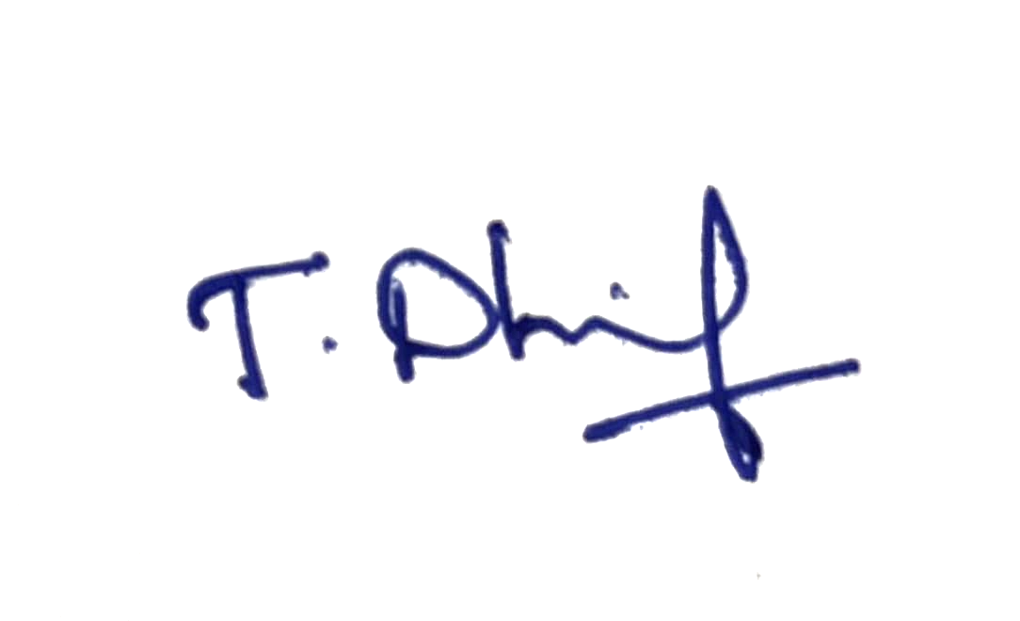  Date: 19th day of September 2025.  Signature:  Name: DHINAKRAN T

(ii) Declaration by the applicant(s) in the convention country
(In case the applicant in India is different than the applicant in the convention country: the applicant in the convention country may sign herein below or applicant in India may upload the assignment from the applicant in the convention country or enclose the said assignment with this application for patent or send the assignment by post/electronic transmission duly authenticated within the prescribed period)

I/We, the applicant(s) in the convention country declare that the applicant(s) herein is/are my/our assignee or legal representative.
- Date
- Signature(s)
- Name(s) of the signatory

(iii) Declaration by the applicant(s)
We the applicant(s) hereby declare(s) that: -
▪ We are in possession of the above-mentioned invention.
▪ The provisional/complete specification relating to the invention is filed with this application.
▪ The invention as disclosed in the specification uses the biological material from India ‬ and the necessary permission from the competent authority shall be submitted by me/us before the grant of patent to me/us.
▪ There is no lawful ground of objection(s) to the grant of the Patent to us.‬
▪ we are the true & first inventor(s).
▪ I am/we are the assignee or legal representative of true & first inventor(s).
▪ The application or each of the applications, particulars of which are given in Paragraph-8, was the first application in convention country/countries in respect of my/our invention(s).
▪ I/We claim the priority from the above mentioned application(s) filed in convention country/countries and state that no application for protection in respect of the invention had been made in a convention country before that date by me/us or by any person from which I/We derive the title.
▪ My/our application in India is based on international application under Patent Cooperation Treaty (PCT) as mentioned in Paragraph-9.
▪ The application is divided out of my /our application particulars of which is given in Paragraph-10 and pray that this application may be treated as deemed to have been filed on DD/MM/YYYY under section 16 of the Act.
▪ The said invention is an improvement in or modification of the invention particulars of which are given in Paragraph-11.

13. FOLLOWING ARE THE ATTACHMENTS WITH THE APPLICATION
(a) Form 2
Item | Details | Fee | Remarks
Complete specification)# | No. of pages: 6
No. of Claim(s) | No. of claims: 6 and  No. of pages: 1
Abstract | No. of pages: 1
No. of Drawing(s) | No. of drawings: 2 and  No. of pages: 1

# In case of a complete specification, if the applicant desires to adopt the drawings filed with his provisional specification as the drawings or part of the drawings for the complete specification under rule 13(4), the number of such pages filed with the provisional specification are required to be mentioned here.
- Complete specification (in conformation with the international application)/as amended before the International Preliminary Examination Authority (IPEA), as applicable (2 copies).
- Sequence listing in electronic form
- Drawings (in conformation with the international application)/as amended before the International Preliminary Examination Authority (IPEA), as applicable (2 copies).
- Priority document(s) or a request to retrieve the priority document(s) from DAS (Digital Access Service) if the applicant had already requested the office of first filing to make the priority document(s) available to DAS.
- Translation of priority document/Specification/International Search Report/International Preliminary Report on Patentability.
- Statement and Undertaking on Form 3
- Declaration of Inventorship on Form 5
- Power of Authority
(j)…………………………………………………………………………………………………..
Total fee ₹……….in Cash/ Banker's Cheque /Bank Draft bearing No.......... Date…………...on …………. Bank.
I/We hereby declare that to the best of my/our knowledge, information and belief the fact and matters slated herein are correct and I/We request that a patent may be granted to me/us for the said invention.

Dated this 19th day of Sep 2025

Signature:

Name: K.S.Rangasamy College of Technology
To,
The Controller of Patents
The Patent Office, at Chennai.
Note: -
- Repeat boxes in case of more than one entry.
- To be signed by the applicant(s) or by authorized registered patent agent otherwise where mentioned.
- Tick (✓)/cross (x) whichever is applicable/not applicable in declaration in paragraph-12.
- Name of the inventor and applicant should be given in full, family name in the beginning.
- Strike out the portion which is/are not applicable.
- For fee: See First Schedule”;

Title:
Voice – Based Health Assistant for Elderly with Multi-Language and Offline support

Abstract:
The proposed invention is a Voice-Based Health Assistant for Elderly with Multi-Language and Offline Support. It integrates voice interaction, health monitoring, and emergency features to enhance elderly care. The system provides medication reminders, appointment scheduling, real time health tracking via wearable integration, and automatic emergency calling upon abnormal vital detection. It further includes a symptom checker chatbot, mood analysis, and cognitive engagement activities to support both physical and mental well-being. With offline capability and multi-language support, the invention ensures accessibility for elderly users in rural or low connectivity regions while offering optional cloud-based extended services.

